Running the MCMC linear regression we can see β0 + β1πi+εi . The peaks of a Density Plot help display where values are concentrated over the interval. For our analysis this is important when looking at $π$ give us visual of what profit share was and how it has spread significantly out from π=0 where we would have seen a perfect continuity between the wage and productivity.

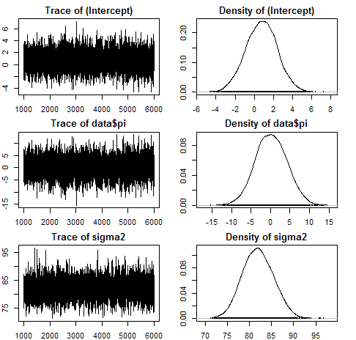

Running R-Stan we are able to make some better use of our data by understanding our variables its effect on our data set. Using a Markov Chain Monte Carlo method known as Hamiltonian Monte Carlo we have the ability to obtain a swquence of random samples from a probability distribution. We will be running a random sample due to the difficulty of doing actual samples. In our model we run 8,000 interations with 3 chains. The purpose of running the 8,000 interations it gave us a big enough sampeling size to see where the data converges after multiple samples. With our sampeling we burn the first 1000 samples in order to eliminate any biases presented from the start of the data. After the burned data is removed it leaves us with 7,000 samples that are ran 3 times giving us 21,000 iterations of useful data.

**R-Stan Rusults**

**mean SEmean sd 2.5% 25% 50% 75% 97.5% n_eff Rhat**

**beta0 0.023 0.000 0.004 0.015 0.020 0.023 0.025 0.031 6686 1**

**beta1 0.943 0.000 0.010 0.923 0.936 0.943 0.950 0.963 6613 1**

**sigma 0.023 0.000 0.000 0.022 0.022 0.023 0.023 0.024 10430 1**

**lp__ 3642.6 0.015 1.249 3639.4 3642.0 3642.9 3643.5 3644.0 7007 1**

in our study we are searching for profit share. The calculations done in figure 1b are resuts calculated under the simulation. The density plot shows that $π_{}^{*}$

The results produced show a similar result to our our original linear model. We the results show that there is a constantly negative profit share. We can see that after running 3 chains of 15,000 iteration and cutting the initiall 7,500 results pulled in order to control for the initial pulls we get the results list. The results show that the stable point in our data is at -.071 after running our results over a sampling postierior.

*Table 6: Summary statisitics from running R-Stan simulation of profit share*

**mean SEmean sd 2.5% 25% 50% 75% 97.5% n_eff Rhat**

**beta0 0.679 0.006 0.910 -1.097 0.068 0.676 1.289 2.476 22500 1**

**beta1 -0.071 0.000 0.030 -0.130 -0.091 -0.071 -0.051 -0.013 22500 1**

**sigma 30.235 0.004 0.648 28.997 29.795 30.228 30.665 31.518 22500 1**

**lp__ -4327.0 0.012 1.242 - 4330.2 -4327.5 -4326.7 -4326.1 -4325.6 11592 1**

*Figure 9: Traceplot and Density table*

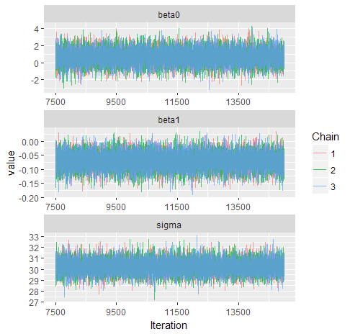

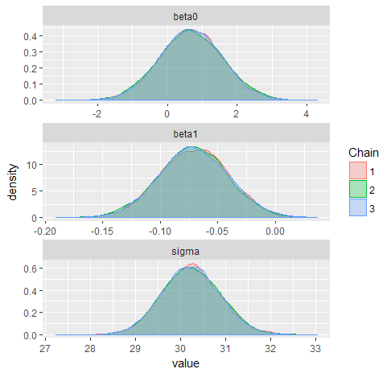

From our results we can conclude that our initial results produced in firgure (1) showing the profit shared ploted the viability parameter will continue to stray from $π=0$. provide further evidence there there is a contiuning serpration in pay comapred to profit share. In figure 7 we have other significant analytical tools that are able to be used to determine the certainty of our data. The running mean and the autocorrelation graph are some of the best determininates to assure we have usful data. Early in the results we can see that there is a small bit of lingering effects from the simulations initial position but we are able to see after multiple trials this disipates and we get results that stablize. This is importat to our study because it gives us the ability to see where the data converges to without having to see a real distribution. We can see with the results listed in figure 7 we converge to our Running mean early on and auto correlation

*Figure 7: Convergance graphs Running Mean and Autocorrelation*

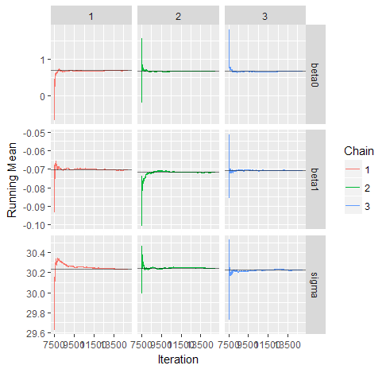

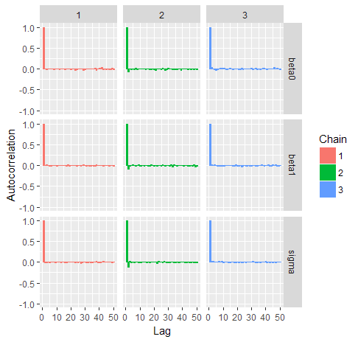

The final figure we see in figure 9 are the Geweke graph. The Geweke graph is a convergence diagnostic of MC based on the eqality of the means. The Geweke is a measurement of the Z-score. The issue we have with the graph below shows are results but there is an issue with the sigma and the first chain. It goes far outside of the of the range that is within the proper diagnosis, the area within the gray.

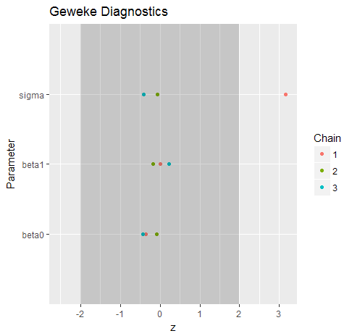

From what we have found with our R-stan results we can say that it gives us better supporting evidence of the findings by Foley and Michel (1999), while our simple linear regressions were a bad use of analytics due to the lack of our data being linear with this type of analysis we are able to see that the original hypothesis holds; showing that profit share is not equal to 0.

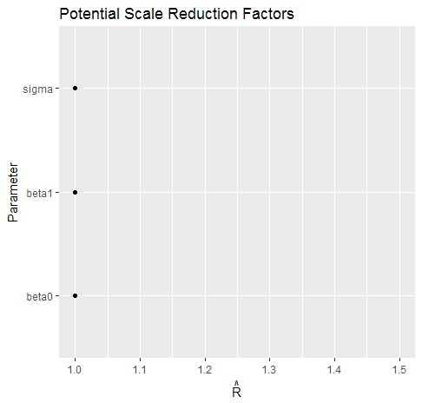

Our $π_{i}^{*}$ that is our viability parameter